HANDS-ON 2 : Data Binding, Lifecycle Hooks & Component Communication
Project Structure:
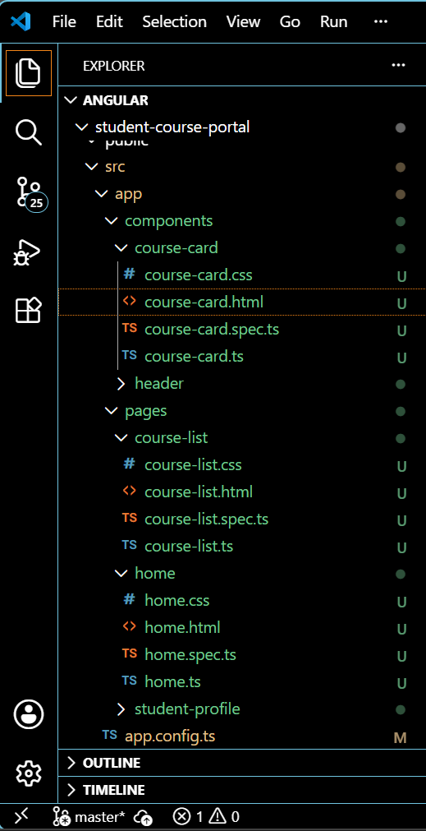

Course-card.html
<div class="course-card">
<h3>{{ course?.name }}</h3>
<p>Code: {{ course?.code }}</p>
<p>Credits: {{ course?.credits }}</p>
<button (click)="enrollRequested.emit(course.id)">Enroll</button>
</div>
Course-card-spec.ts
import { ComponentFixture, TestBed } from '@angular/core/testing';

import { CourseCard } from './course-card';

describe('CourseCard', () => {
let component: CourseCard;
let fixture: ComponentFixture<CourseCard>;

beforeEach(async () => {
await TestBed.configureTestingModule({
imports: [CourseCard]
})
.compileComponents();

fixture = TestBed.createComponent(CourseCard);
component = fixture.componentInstance;
fixture.detectChanges();
});

it('should create', () => {
expect(component).toBeTruthy();
});
});

Course-card.ts
import { Component, Input, Output, EventEmitter, OnChanges, SimpleChanges } from '@angular/core';

@Component({
selector: 'app-course-card',
imports: [],
templateUrl: './course-card.html',
styleUrl: './course-card.css'
})
export class CourseCard implements OnChanges {
@Input() course: any;
@Output() enrollRequested = new EventEmitter<number>();

ngOnChanges(changes: SimpleChanges) {
console.log('Course changed:', changes['course'].previousValue, '->', changes['course'].currentValue);
}
}
Course-list.html
<div class="course-list">
<app-course-card *ngFor="let c of courses" [course]="c" (enrollRequested)="onEnroll($event)"></app-course-card>
</div>

<p *ngIf="selectedCourseId">Selected course ID: {{ selectedCourseId }}</p>
Course-list-spec.ts
import { ComponentFixture, TestBed } from '@angular/core/testing';

import { CourseList } from './course-list';

describe('CourseList', () => {
let component: CourseList;
let fixture: ComponentFixture<CourseList>;

beforeEach(async () => {
await TestBed.configureTestingModule({
imports: [CourseList]
})
.compileComponents();

fixture = TestBed.createComponent(CourseList);
component = fixture.componentInstance;
fixture.detectChanges();
});

it('should create', () => {
expect(component).toBeTruthy();
});
});

Course-list.ts
import { Component } from '@angular/core';
import { CommonModule } from '@angular/common';
import { CourseCard } from '../../components/course-card/course-card';

@Component({
selector: 'app-course-list',
imports: [CourseCard, CommonModule],
templateUrl: './course-list.html',
styleUrl: './course-list.css'
})
export class CourseList {
courses = [
{ id: 1, name: 'Angular Basics', code: 'ANG101', credits: 3 },
{ id: 2, name: 'TypeScript Deep Dive', code: 'TS201', credits: 4 },
{ id: 3, name: 'RxJS Fundamentals', code: 'RXJ301', credits: 3 },
];
selectedCourseId: number | null = null;

onEnroll(courseId: number) {
console.log('Enrolling in course: ' + courseId);
this.selectedCourseId = courseId;
}
}
Home.css
:host {
display: block;
max-width: 720px;
margin: 2rem auto;
padding: 1.5rem 2rem;
font-family: 'Segoe UI', Arial, sans-serif;
background: #ffffff;
border-radius: 10px;
box-shadow: 0 2px 10px rgba(0, 0, 0, 0.08);
}

h1 {
color: #222;
margin-bottom: 1.2rem;
}

button {
padding: 0.5rem 1.2rem;
margin-right: 0.6rem;
border: none;
border-radius: 6px;
background: #4a6cf7;
color: white;
font-size: 0.95rem;
cursor: pointer;
transition: background 0.2s ease;
}

button:hover {
background: #3a56d4;
}

button:disabled {
background: #ccc;
cursor: not-allowed;
}

p {
color: #555;
margin: 0.8rem 0;
}

input {
width: 100%;
padding: 0.6rem 0.8rem;
margin-top: 1rem;
border: 1px solid #ccc;
border-radius: 6px;
font-size: 0.95rem;
box-sizing: border-box;
}

input:focus {
outline: none;
border-color: #4a6cf7;
}
Home.html
<h1>{{ portalName }}</h1>

<button [disabled]="!isPortalActive">Enroll Now</button>
<button (click)="onEnrollClick()">Trigger Enroll</button>

<p>{{ message }}</p>

<input [(ngModel)]="searchTerm" placeholder="Search courses...">
<p>Searching for: {{ searchTerm }}</p>

<!--
[property] binding is one-way: component -> DOM only.
[(ngModel)] is two-way binding: DOM <-> component, syncs both directions.
-->
Home-spec.ts
import { ComponentFixture, TestBed } from '@angular/core/testing';

import { Home } from './home';

describe('Home', () => {
let component: Home;
let fixture: ComponentFixture<Home>;

beforeEach(async () => {
await TestBed.configureTestingModule({
imports: [Home]
})
.compileComponents();

fixture = TestBed.createComponent(Home);
component = fixture.componentInstance;
fixture.detectChanges();
});

it('should create', () => {
expect(component).toBeTruthy();
});
});

Home.ts
import { Component, OnInit, OnDestroy } from '@angular/core';
import { FormsModule } from '@angular/forms';

@Component({
selector: 'app-home',
imports: [FormsModule],
templateUrl: './home.html',
styleUrl: './home.css'
})
export class Home implements OnInit, OnDestroy {
portalName = 'Student Course Portal';
isPortalActive = true;
message = '';
searchTerm = '';
courseCount = 0;

onEnrollClick() {
this.message = 'Enrollment opened!';
}

ngOnInit() {
this.courseCount = 5; // simulated course count
console.log('HomeComponent initialised — courses loaded');
}

ngOnDestroy() {
console.log('HomeComponent destroyed');
}
}
OUTPUT:
